Testing Plan for Video Rental

|  |  |  |
| --- | --- | --- |
| **Functionality** | **Test Scenario** | **Result (Pass /Fail)** |
| Adding Movies | 1.   Add a Movie and check if it adds to the database and shows in the Data-grid     2.  Add fees for the videos, if videos are older than 5 years (Release Date) then they cost $2 otherwise they cost $5      3.List **who borrows the most videos** and list       **what are the most popular videos**. | Pass  Pass  Pass  Pass |
| Adding Customers | •        Add a customer and check if it adds to the database and shows in the data-grid | Pass |
|  |  |  |
| Update Movies / Customer | •        *Should update details of the respective movie and customer only* | pass |
| Delete Movies | •        Cannot delete rented movies  •        Delete movies | pass |
| Delete Customer | •        Delete customer | pass |

Adding Movies: Pass

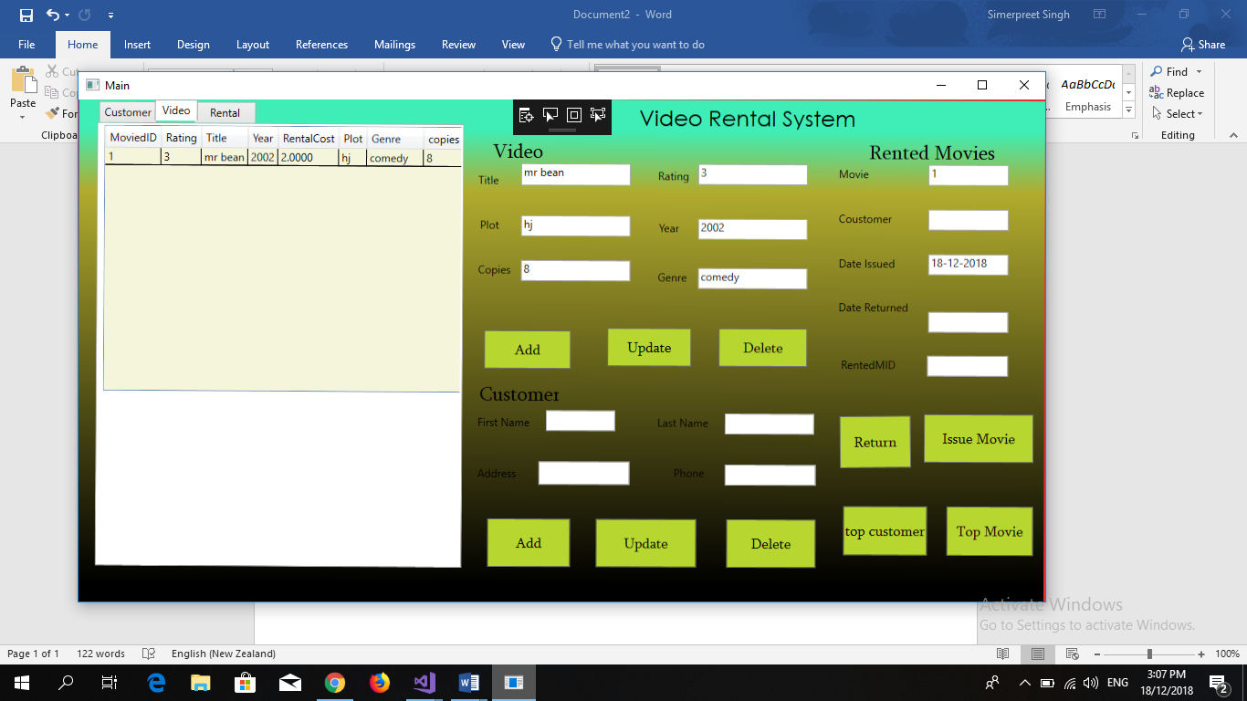

Adding Customer: pass

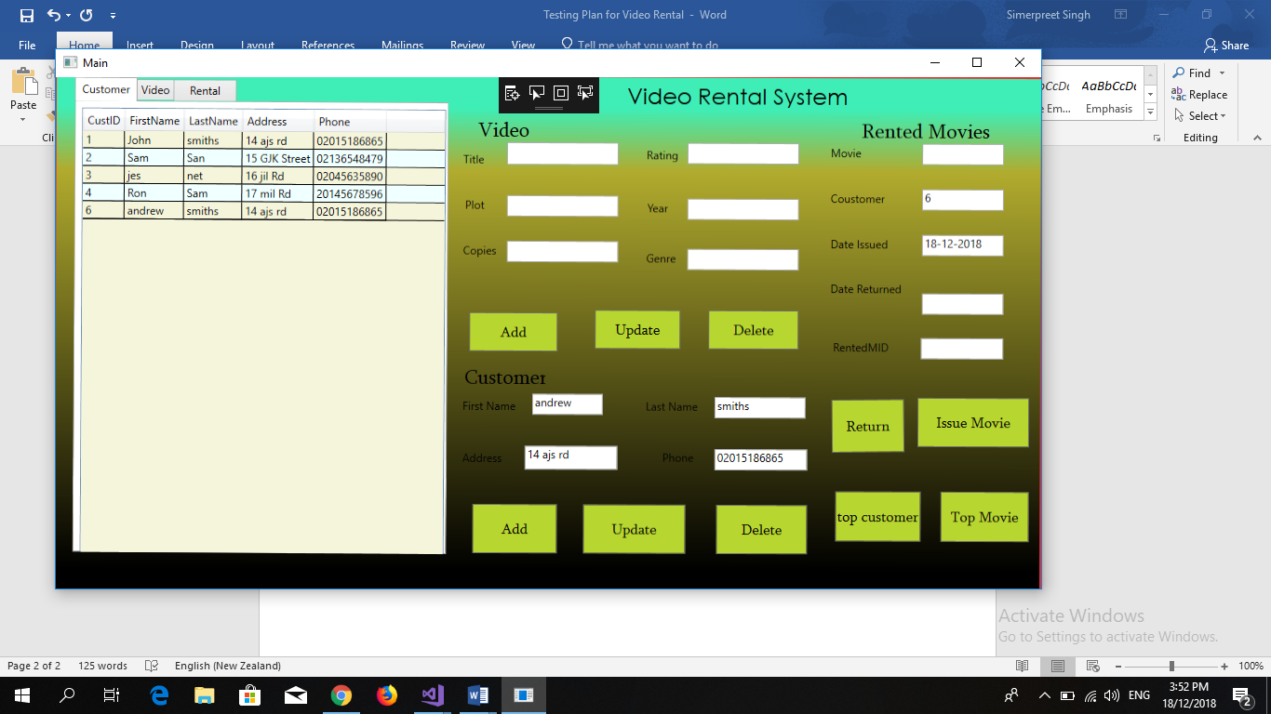

Update Movie and Customer: Pass

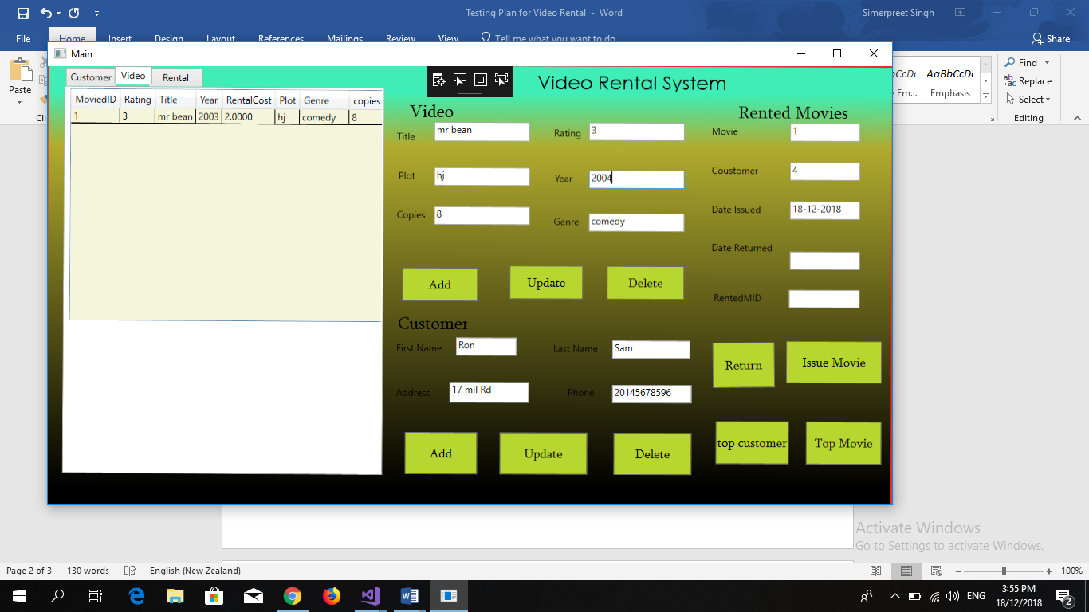

Delete Movie: Pass

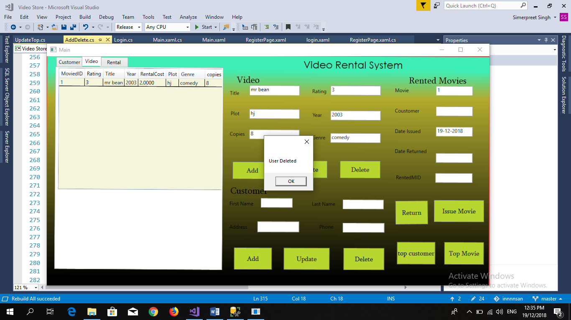

Delete Customer: Pass

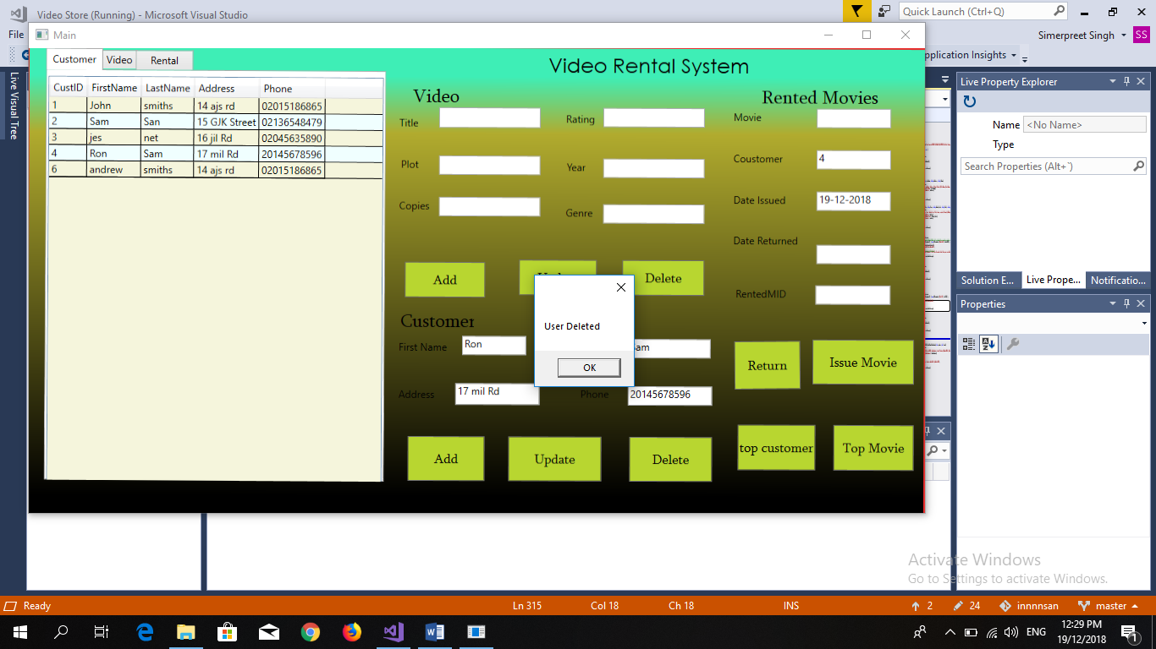

Sign-in:

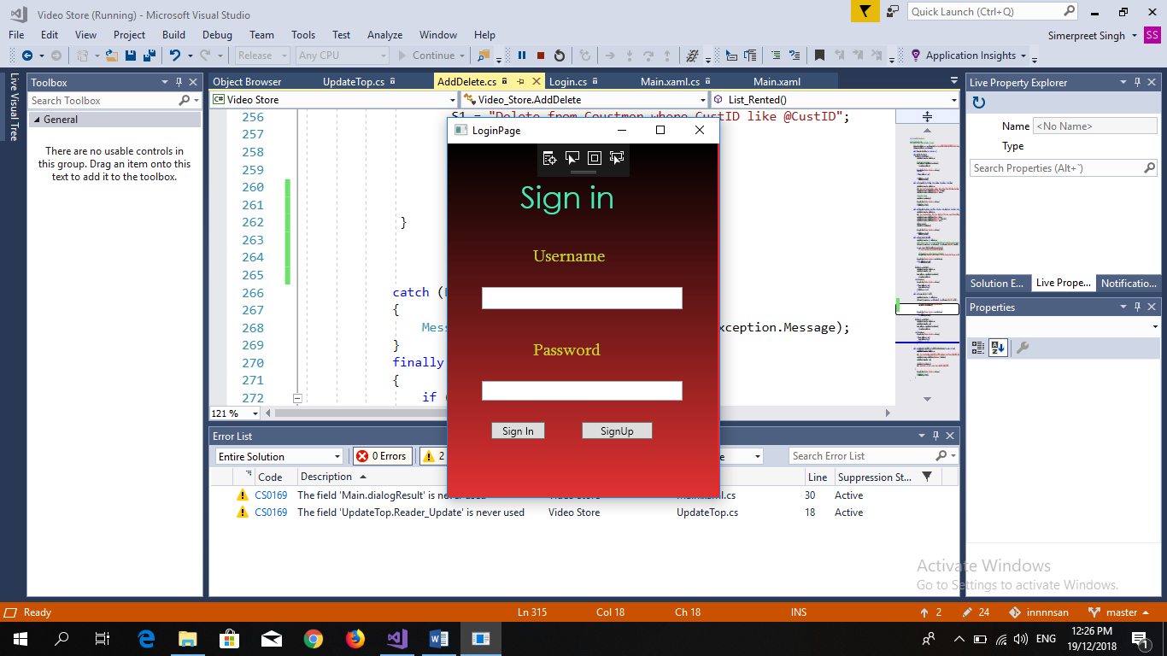

Sign-Up:

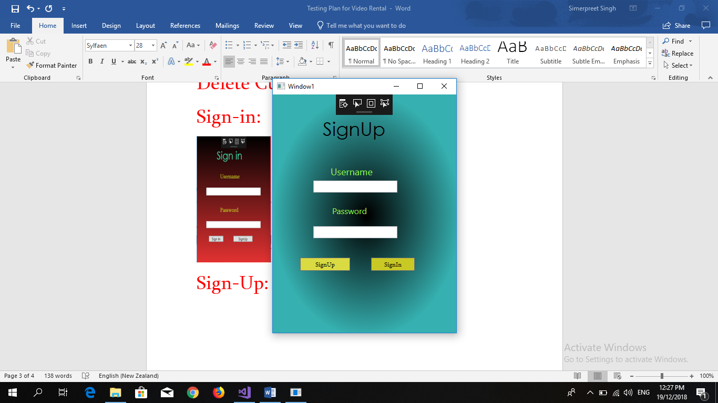

Top Customer: Pass

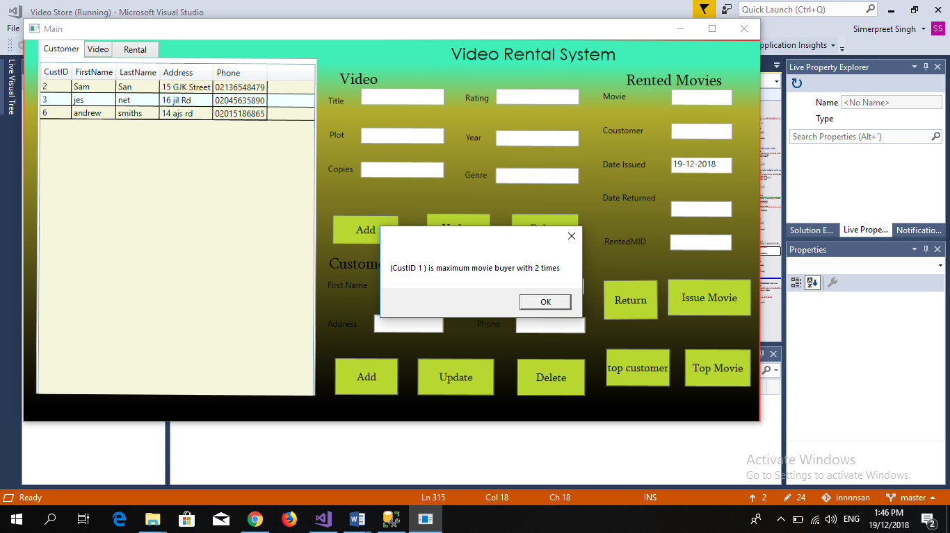

Top Movie: Pass

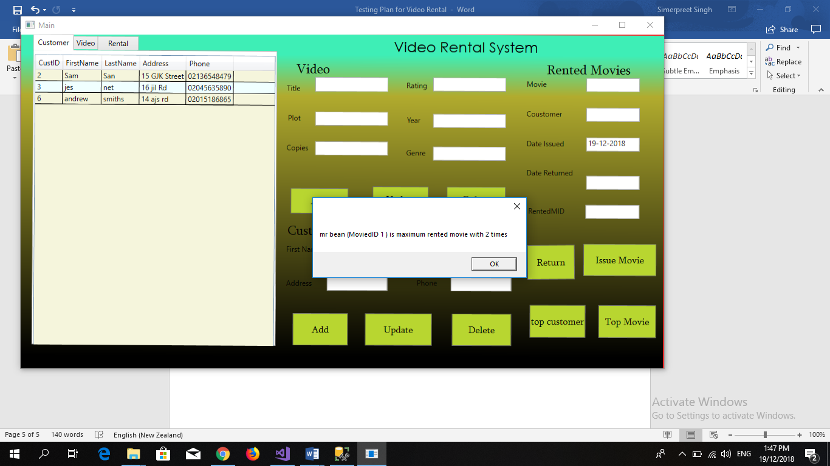

Top Customer: Pass

